| Gerb-BMSTU_01 | **Министерство науки и высшего образования Российской Федерации**  **Федеральное государственное бюджетное образовательное учреждение**  **высшего образования**  **«Московский государственный технический университет**  **имени Н.Э. Баумана**  **(национальный исследовательский университет)»**  **(МГТУ им. Н.Э. Баумана)** |
| --- | --- |

ФАКУЛЬТЕТ **ИНФОРМАТИКА И СИСТЕМЫ УПРАВЛЕНИЯ**

КАФЕДРА **КОМПЬЮТЕРНЫЕ СИСТЕМЫ И СЕТИ (ИУ6)**

НАПРАВЛЕНИЕ ПОДГОТОВКИ **09.03.01 Информатика и вычислительная техника**

**ОТЧЕТ**

| **по лабораторной работе №** | 8 |
| --- | --- |



RUBY ON RAILS

**Дисциплина:** Языки Интернет-программирования

| Студент | ИУ6-33Б |  | 01.11.2021 | Хоанг Т.Ф. |
| --- | --- | --- | --- | --- |
|  | (Группа) |  | (Подпись, дата) | (И.О. Фамилия) |
|  |  |  |  |  |
| Преподаватель |  |  |  |  |
|  |  |  | (Подпись, дата) | (И.О. Фамилия) |

Москва, 2021

**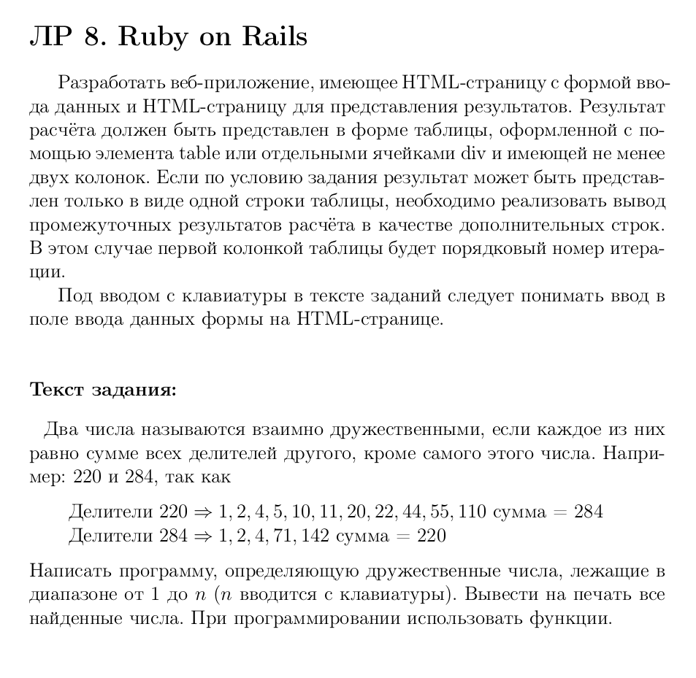**

**routes.rb**

Rails.application.routes.draw do

root 'friend\_num#home'

post '/result', to: 'friend\_num#result', as: 'friend\_num'

# For details on the DSL available within this file, see https://guides.rubyonrails.org/routing.html

end

**app/controllers:**

**friend\_num\_controller.rb**

class FriendNumController < ApplicationController

attr\_accessor :res, :num

def home; end

def sum\_divisors(arg)

sum = 0

(1...arg).each do |div|

sum += div if arg % div == 0

end

sum

end

def check

arr = Array.new(0)

sum = Array.new(num)

(1..num).each {|index| sum[index] = sum\_divisors(index)}

(1..num - 1).each do |num1|

(num1..num).each do |num2|

arr.append([num1, num2]) if num1 != num2 && num1 == sum[num2] && sum[num1] == num2

end

end

arr

end

def result

@num = params[:num].to\_i

@res = check

end

end

**app/views/friend\_num**

**home.html.erb**

<!DOCTYPE html>

<html lang="en">

<head>

<meta charset="UTF-8">

<meta http-equiv="X-UA-Compatible" content="IE=edge">

<meta name="viewport" content="width=device-width, initial-scale=1.0">

<link href="https://cdn.jsdelivr.net/npm/bootstrap@5.1.3/dist/css/bootstrap.min.css" rel="stylesheet" integrity="sha384-1BmE4kWBq78iYhFldvKuhfTAU6auU8tT94WrHftjDbrCEXSU1oBoqyl2QvZ6jIW3" crossorigin="anonymous">

<title></title>

</head>

<body>

<h1>FRIEND NUMBERS</h1>

<p>Two numbers are called friend if each of them is equal to the sum of all divisors of another, except for this number itself. Find every friend numbers from 1 to n</p>

<%= form\_with(url: friend\_num\_path, method: "post", local: true) do |form|%>

<%= form.label :num, "Enter n: " %>

<%= form.text\_field :num %>

<div class="button">

<%= form.submit "Get result" %>

</div>

<% end %>

</body>

</html>

**result.html.erb**

<!DOCTYPE html>

<html lang="en">

<head>

<meta charset="UTF-8">

<meta http-equiv="X-UA-Compatible" content="IE=edge">

<meta name="viewport" content="width=device-width, initial-scale=1.0">

<link href="https://cdn.jsdelivr.net/npm/bootstrap@5.1.3/dist/css/bootstrap.min.css" rel="stylesheet" integrity="sha384-1BmE4kWBq78iYhFldvKuhfTAU6auU8tT94WrHftjDbrCEXSU1oBoqyl2QvZ6jIW3" crossorigin="anonymous">

<title>Result</title>

</head>

<body>

<h1>RESULT TABLE - Friend numbers</h1>

<table class="table table-bordered">

<tr>

<th>The first number</th>

<th>The second number</th>

</tr>

<% @res.each do |couple| %>

<tr>

<td><%= couple[0] %> </td>

<td><%= couple[1] %> </td>

</tr>

<% end %>

</table>

</body>

</html>

**test/controllers**

**friend\_num\_controller\_test.rb**

require "test\_helper"

class FriendNumControllerTest < ActionDispatch::IntegrationTest

setup do

@num = 2000

@result = [[220,284],[1184,1210]]

end

test "get home" do

get root\_url

assert\_response :success

end

test "get result" do

post friend\_num\_url, params: {num:@num}

assert\_response :success

assert\_equal assigns[:res], @result

end

# test "the truth" do

# assert true

# end

end

